Project Design Phase
Solution Architecture

Date | 01 October 2026
Team ID | SWTID-2026-2085
Project Name | Import Data Using Transform Maps (Spreadsheet)
Maximum Marks | 4 Marks

Solution Architecture

The solution bridges a common business problem, slow and error-prone manual data entry from spreadsheets, and a technology solution: a transform-map-based import system. Its goals are to:

- Find the best technical solution for bulk spreadsheet data entry, using a staging table and a configurable transform map.

- Describe the structure and behavior of the software to project stakeholders: a React client, a Node.js/Express server, and MongoDB storage.

- Define features, development phases, and solution requirements: upload, mapping, validation, coalesce, import, and history.

- Provide specifications by which the solution is defined, managed, and delivered: REST APIs, database collections, and role-based access.

Example - Solution Architecture Diagram:
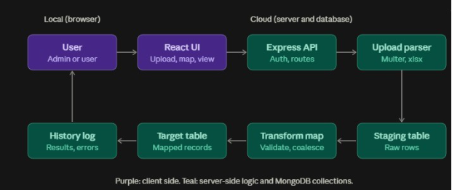

Architecture and Data Flow

Figure 1: Architecture and data flow of the spreadsheet import application (diagram above).

- The user logs in and uploads an .xlsx/.csv file through the React UI.

- The Express API checks the JWT token and the user's role.

- The upload parser reads the file and saves the raw rows into the staging table.

- The transform map matches source columns to target fields, validates the data, and applies the coalesce rule to avoid duplicates.

- Valid records are inserted or updated in the target table.

- The history log stores the inserted, updated, and failed counts, and the results are returned to the user in the UI.

